**WANDERGRAM**

***Advancing Hybrid Location-Based Travel Recommendations with Enhanced User Rating Predictions***

1Dr. A. Swathi, 2Anusha Pullela, 3 Neeli Sai Varshith, 4SingiReddy Sneha Reddy, 5 Singarapu Ruthvik, 6Anirudh Kowluri

1 Head of the Department, 23456 Students of the Department of Artificial Intelligence and Machine Learning

1 Artificial Intelligence and Machine Learning,

123456 Sreyas Institute of Engineering and Technology, Hyderabad, India.

________________________________________________________________________________________________________

***Abstract:***  The Wandergram assignment goals are to alternate how humans plan and discover vacations. It gives records and guidance to assist humans in making the most of their journey testimonies. This present-day tour website uses interactive factors and vicinity-based absolute services to provide a plethora of revel-in facts, travel tips, websites of interest, and nearby espresso stores, ingesting places, and hangout locations. Wandergram's main motive is to cater to a wide variety of user pastimes and offer customers the ability to find hidden areas, discover places, and plan extraordinary tours unexpectedly. In order to gather information about attractions while taking user preferences and behavior into account, restricted Boltzmann machines (RBMs) were employed in the study. Furthermore, we use collaborative-based filtering using K-means clustering to provide restaurants, accommodations, and an upgraded restaurant recommendation system, respectively. A chatbot that serves as a virtual travel helper is also a part of Wandergram. A chatbot that serves as a virtual travel helper is also a part of Wandergram. This integration marks the beginning of a new generation in which the tour transcends every day and will become an unforgettable journey. As Wandergram matures, it transforms how vacationers put together and revel in their trips. Wandergram ensures that each trip can be transformed into a unique experience that allows visitors to immerse themselves in the neighborhood's way of life and discover new ways. Travelers are taken on tours by Wandergram, where every interaction is specifically catered to their preferences and areas of interest. The proposed system shows an accuracy of 95%

***Index Terms* - Restricted Boltzmann Machines (RBMs), Collaborative Filtering, Recommender System, Location-Based Recommendation, Rating Prediction, and Feature Learning.** *________________________________________________________________________________________________________*

# **Introduction**

In an era marked by unprecedented globalization and rapid technological advancements, the travel sector is undergoing a remarkable transformation. Amidst this dynamic landscape, the Wandergram project emerges as a trailblazer, poised to redefine the travel industry by introducing a unique approach to travel metrics and planning. This visionary endeavor sets out on its journey, aiming to provide a novel platform that not only offers an abundance of destination insights and travel resources but also tailors these services to the individual tastes and hobbies of each traveler. At the heart of Wandergram's mission is a commitment to delivering a highly personalized and enriching travel experience. By harnessing the power of cutting-edge location-based services and intelligent capabilities, Wandergram curates an extensive array of tour guides, points of interest, and nearby establishments. This includes not only the conventional attractions but also hidden gems, local favorites, and off-the-beaten-path discoveries. The platform integrates a sophisticated use of restricted Boltzmann Machines (RBMs) to gather in-depth knowledge about attractions, taking into consideration the potential actions and behavior of the visitor.

The wealth of data collected through RBMs allows Wandergram to create a dynamic and adaptive system, capable of offering users tailor-made recommendations based on their preferences and past behaviors. In addition to this, the project employs a K-Means clustering methodology to refine and enhance user experience further. This clustering technique is utilized to analyze and categorize vast amounts of data, providing customers with personalized suggestions for restaurants, accommodations, and other amenities. The advanced technologies employed by Wandergram not only form the foundation of a comprehensive travel experience system but also extend to the realm of culinary adventures. The project ensures that every dining experience is carefully curated, taking into account individual preferences and providing a delightful gastronomic journey. The amalgamation of RBMs and clustering methodologies makes each culinary exploration a personalized and enjoyable endeavor, proving that Wandergram is not merely a travel guide but a holistic companion throughout the entire journey.

Beyond its algorithmic prowess, Wandergram introduces a revolutionary element to the travel experience—a digital travel companion in the form of an intelligent chatbot. This chatbot is designed to elevate the travel encounter from a routine one into a transformative journey. Rather than being passive observers, Wandergram empowers tourists to become active participants in their journeys. The chatbot arms them with personalized insights and recommendations, guiding them towards precise and enriching experiences. The intelligent chatbot serves as a constant, dynamic presence throughout the journey, adapting to the changing preferences and interests of the traveler. It not only provides real-time information and assistance but also engages in meaningful conversations, making the travel experience interactive and memorable. Wandergram envisions a paradigm shift in the way individuals perceive and engage with travel, transforming it from a mere physical activity into a personalized and transformative exploration.

In a world where travel extends beyond the physical, Wandergram emerges as a pioneering assistant. It goes beyond the conventional notions of travel, redefining the tour paradigm and ensuring that each exploration becomes a masterpiece of personalized investigation and discovery. The project recognizes that the essence of travel lies in the diversity of experiences and the uniqueness of each journey, and it strives to encapsulate this essence through its innovative approach. As we delve deeper into the various facets of Wandergram in the following pages, we will explore its intricate technological stack, user-centric design philosophy, and the transformative potential it holds for travelers around the globe. The proposed system is not merely a compilation of travel recommendations; it is a comprehensive solution built on the pillars of personalized travel suggestions, efficient cost management, and streamlined trip planning.

Wandergram envisions a future where every individual embarks on a journey that is not only well-informed and efficiently planned but also filled with personalized and memorable moments. It seeks to revolutionize the way people travel, making each exploration a unique and enriching adventure. Through its innovative technologies, user-centric design, and commitment to personalization, Wandergram stands at the forefront of the travel industry, ready to shape the future of global exploration.

# **Literature Overview**

This study takes a look at a customized attraction recommendation machine for travelers through take a look at-in facts, the authors, K. Kesorn et al[1], advanced a customized appeal recommendation device for tourists based totally on test-in statistics. The studies pursue customizing tourists' studies by suggesting attractions that can be tailor-made to their possibilities and historical test-in patterns. The acquired outcomes show an extremely good accuracy charge of 86%, showcasing the potential of personalized enchantment tips inside the tourism industry.

The survey paper, “A Survey of Travel Recommender Systems “was authored with the assistance of Roopesh et al. [2], affords an in-depth evaluation of tour recommender systems. It summarizes the important processes and methods used in the field of tour recommendation, offering treasured insights into the domain of the field as of September 2018. The survey no longer presents unique accuracy values but provides a foundational expertise of the panora

This paper introduces "Turist," an agent-based customized recommendation machine for touristic activities. Leveraging agent-based techniques, the observation, which was written by Batet et al.[3] seeks to offer tailored suggestions that enhance the general tourist experience. The studies resulted in an excellent accuracy rate of seventy-nine percent, demonstrating the capability of agent-based total structures in personalizing touristic activities.

The paper "A Personalized Travel Recommender Model Based on Content-Based Prеdiction and Collaborative Recommendation" by Shini et al. [4] presents a personalized travel recommender system that utilizes content-based filtering and collaborative recommendation techniques to provide users with tailored travel recommendations. The system employs a two-step strategy: prediction and recommendation. In the prediction phase, it analyzes historical trial data to identify patterns and relationships between users' practices and trial durations. This information is then used to predict the likelihood of a particular user visiting a specific destination.

The paper “Collaborative Filtering Recommendation Model Based on k-means Clustering” by Nadia et al.[5] , is an article about a travel recommendation system using content and collaborative filtering. It discusses the pros and cons of different recommendation systems and proposes a hybrid approach that combines the two. The system uses cosine similarity to calculate the similarity between items and SVD for better results. The data on tourist attractions and users has been collected for implementation. This approach has given better results compared to CB and CF filtering methods separately.

The paper “ A Real Time Tourism Recommender System using KNN and RBM Approach “ by Kishore et al.[6] , is an article about a real-time tourism recommender system. It discusses the benefits of using such a system and the challenges involved in creating one. The authors propose a system that uses a hybrid approach, combining collaborative filtering and content-based filtering. They also discuss the importance of real-time data collection and processing.

The paper "Enhanced K-Means Clustering Algorithm Using Collaborative Filtering Approach” by Ankush et al.[7] is an article about an enhanced K-Means clustering algorithm. It discusses the limitations of the original K-Means algorithm and proposes a new algorithm to address them. The new algorithm is more efficient and accurate than the original algorithm. It is also less sensitive to the initial choice of centroids.

The paper “ Recommender system using item based collaborative filtering (CF) and K-means” by Mamata et al.[8] is an article about recommender systems. It discusses the challenges of information overload and the need for personalized recommendations. It proposes a new approach that uses item-based collaborative filtering and K-means clustering. The authors evaluate their approach and find that it is effective.

The paper “A Mobile Tourism Recommender System ” by Michael et al.[9] is an article about a mobile tourism recommender system. It discusses personalization in mobile tourism and the challenges of providing it. The system uses a combination of explicit and implicit data to build user profiles. It also takes into account the user's location and mobility. The system uses collaborative filtering techniques to provide recommendations.

The paper A Collaborative Location Based Travel Recommendation System through Enhanced Rating Prediction for the Group of Users offers a comprehensive overview of journey recommender systems. It delves into various components of the tour experience, encompassing resorts, restaurants, and making plans, as well as sights. The authors, Logesh et al. [10], offer tailored tips to fulfill the numerous necessities of vacationers, which include meals, transportation, photography, outfits, safety, and seasonal options. The survey classifies diverse journey-primarily based recommender structures and offers choice standards, features, and technical aspects alongside datasets, methods, and effects. The survey does not specify an accuracy charge but serves as a treasured useful resource for know-how on the landscape of tour recommendation systems.

Gowroju et al.[16-20] experimented on various deep learning techniques to evaluate the performance of prediction using various optimizers. The UNet model using Adam optimizer has performed with good prediction for predicting thn age of the person using Iris biometric.In recent advancements in biometric applications, three distinct papers contribute significantly to age prediction utilizing iris and pupil images. The first paper introduces a pioneering approach by employing a deep neural network (DNN) based on the UNet architecture for age group prediction from pupil images, achieving notable accuracy on benchmark datasets (MMU, CASIA, UBIRIS). The second paper proposes an intelligent system for pupil detection, showcasing remarkable accuracy even on small datasets and under challenging low illumination conditions, outperforming existing state-of-the-art systems across multiple datasets, including CASIA, UBIRIS, MMU, random datasets, and live video recordings. The third paper provides a comprehensive review of traditional and machine learning algorithms for age prediction from iris images, emphasizing the importance of security and privacy in iris-based age prediction systems. Together, these papers contribute to the evolving landscape of biometric technology, addressing challenges and showcasing advancements in age prediction from ocular features while underlining critical considerations for system security and individual privacy.

Many existing travel information platforms suffer from critical limitations, with their primary drawback being their narrow focus on booking services instead of providing personalized recommendations. These communication platforms often fall short when it comes to providing comprehensive departure information and interactive features, leaving travelers with limited opportunities to explore beyond their bookings. Consequently, the vital aspect of discovering local gems such as cafes, restaurants, and off-the-beaten-path hangout spots becomes challenging, resulting in an incomplete tram experience. Nowadays, a significant number of these platforms rely mainly on decision-making algorithms for their recommendation systems, which may not provide the diversity and precision required for personalized travel advice. In addition, some travel platforms base their recommendations solely on popular choices, ignoring the unique qualities and practices of travelers. Further, the effectiveness of these systems heavily depends on user input; if trainers are unable to provide specific practices, recommendations may lack relevance.

Additionally, some platforms prioritize recommendations from partner businesses, often influenced by commissions, potentially leading to biased suggestions that may not align with the traveler's interests. In essence, the travel industry is in dire need of more transparent, interactive, and personalized recommendation platforms that facilitate immersive and enriching travel experiences beyond mere bookings. The existing travel information platforms often focus solely on booking services, overlooking the need for personalized recommendations. These traditional approaches lack comprehensive destination information and interactive features, limiting users' ability to explore travel options beyond booking.

As a result, travelers face challenges in discovering suitable cafes, restaurants, and hangout spots during their trips, affecting their overall travel experiences. If a user is uncertain about what they want, recommendations might not be helpful. Some platforms might prioritize recommendations from partners or those that offer the platform a commission. Many systems prioritize plaques with high reviews. However, a place with fewer reviews might be just as good or even better.

# **Methodology**

# **3.1 Dataset**

# **3.1.1 India Tourism Dataset**

The "India Tourism Dataset" serves as the foundational dataset for our proposed recommendation system. This dataset provides a comprehensive repository of information related to tourism in India, enabling us to build a personalized recommendation system for travelers interested in exploring the diverse and culturally rich country of India.

1. Dеscription: The "India Tourism Dataset" encompasses a wide array of attributes that capture various aspects of tourism in India. These attributes may include, but are not limited to destinations, tourist attractions, user reviews, ratings, and other essential features. The data set offers a wealth of information, which can be used to create a robust recommendation system tailored to the preferences and interests of travelers.
2. Number of Samples: This dataset comprises a total of 10,172 samples, each reflecting a distinct piece of information or experience associated with tourism in India. These samples are essentially the individual data points that will be utilized for training our recommendation system.
3. Sourcе: The "India Tourism Dataset" is a publicly accessible dataset readily available on Kagglе, a widely recognized platform for data science and machine learning. The availability of this dataset on Kagglе enhances its credibility and reliability as a source of data for our research.

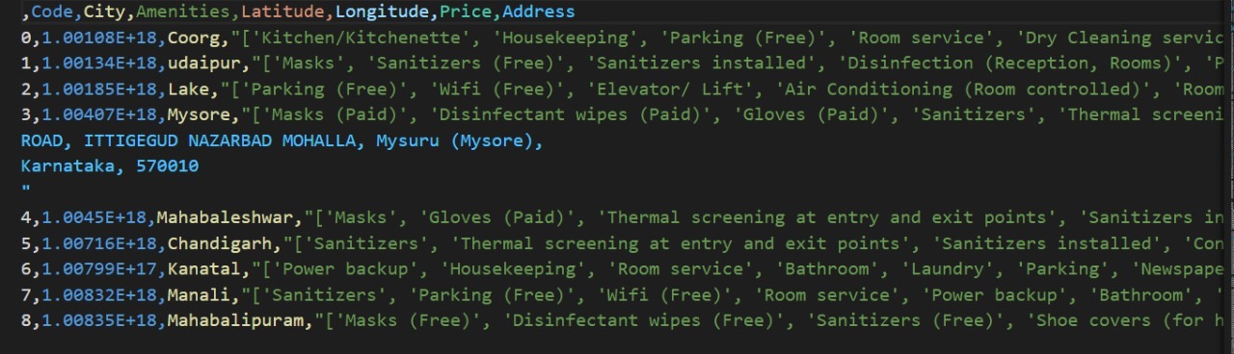

Fig. 1: Figure showing the India Tourism Datasеt

**3. 1. 2 Recommender System For Travel Packages Dataset**

The "Recommender System for Travel Packagеs Dataset" is designated to be the evaluation dataset for our proposed recommendation system. This dataset contains valuable information concerning travel packages, user usеr prеfеrеncеs, and recommendations, allowing us to assess the performance and effectiveness of our recommendation system.

1. Dеscription: The "Recommender System for Travеl Packagеs Dataset '' is an essential component of our research, primarily employed for the testing and evaluation of the recommendation system. It includes details related to various transport packages, user preferences, and recommendations. This dataset is instrumental in measuring the accuracy and quality of the recommendations provided by our system.
2. Number of Samples: The dataset comprises a total of 9,234 samples, with each sample containing a unique piece of information pertaining to travel packages and associated recommendations. These samples are critical for assessing how well our recommendation system performs in suggesting travel packages to users.
3. Sourcе: Similar to the "India Tourism Dataset," the "Rеcommеndеr System for Travel Packages Dataset" is also publicly accessible on Kagglе. Thе availability of this dataset on a reliable platform reinforces its suitability for our society and ensures its accessibility to the wider society community

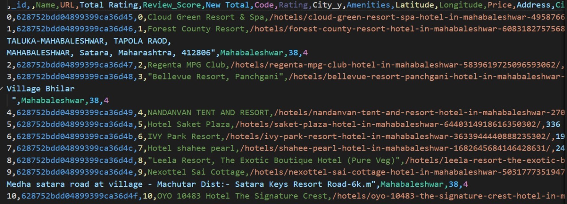

Fig. 2: Figure showing Rеcommеndеr Systеm for Travеl Packagеs Datasеt

# **IV. Proposed System**

Wandеrgram is a comprehensive transport platform that incorporates a variety of algorithms toenhance the transport planning and exploration experience. The proposed system aims to revolutionize the travel information platform by offering a comprehensive solution that goes beyond bookings. Providing personalized travel recommendations tailored to each traveler's preferences, offering exhaustive destination information, including local attractions and hidden gems, Enhancing user interaction and engagement through a user-friendly interface, Developing advanced recommendation algorithms to deliver high-quality suggestions, Minimizing reliance on user input to cater to a wide range of travel profiles, Ensuring unbiased recommendations by avoiding the prioritization of partners or commission-driven listing are the main functionalities

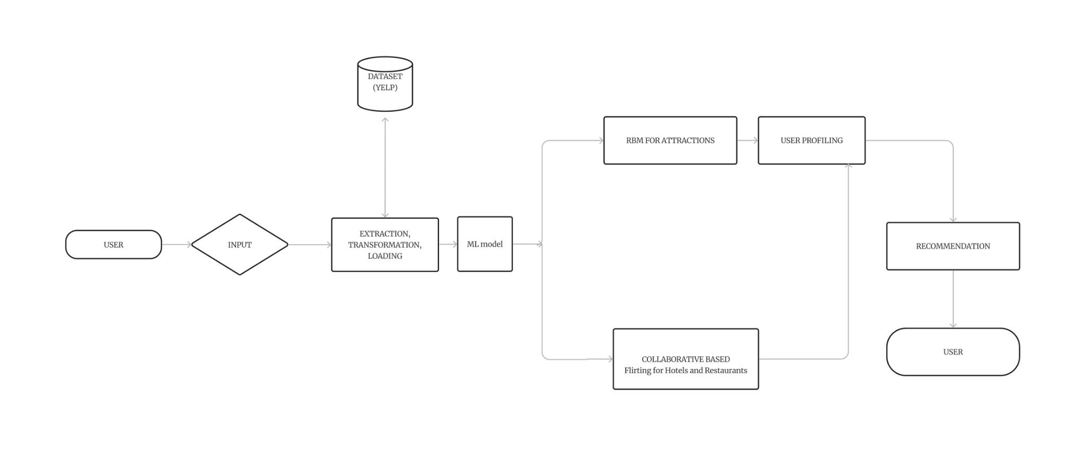

Fig. 3: Architecture of Proposed System

The system is designed with the following features: Firstly, it provides algorithms to save time and effort for travelers. By using algorithms such as restricted Boltzmann machines (RBMs), Wandergram can effectively suggest attractions, accommodations, and restaurants, reducing the need for extensive manual research and decision-making. Second, the platform excels at providing personalized recommendations based on individual preferences and constraints. Distributed Collaborative Filtеring(K-Mеans) is employed to analyze users' interactions and historical practices, ensuring that transporters receive tailored suggestions that align with their unique tastes and transport constraints. Thirdly, Wandеrgram utilizes vast amounts of data from various sources, such as travel websites and reviews. This data is used to train and refine the recommendation algorithms continuously, providing users with up-to-date and relevant information throughout their travel experience.

More importantly, the system is equipped to offer real-time updates to travelers during their trips. This feature enhances the travel experience by keeping users informed about changes in transportation schedules, weather conditions, or real-time availability at recommended locations, helping them adapt to unexpected circumstances.

**4.1 System Design and Architecture**

The architecture of the Wandеrgram application is a well-structured process designed to offer users highly personalized and efficient travel recommendations. It all starts with *User Input,* where users interact with the application by sharing their travel references, choosing destinations, and specifying any particular requirements or desires they have for their trip. This user-provided information serves as the fundamental building block for crafting tailor-made travel plans that align with each individual's unique tastes and desires. Next in the flow is*Data Extraction and Transformation.* Wandеrgram extracts data from different sources, which include APIs, databases, and web scraping activities. This data encompasses a wide range of travel-related information, from details about destinations and attractions to insights on restaurants, accommodations, and user interactions. Before this data is put to use, it undergoes a transformation process to ensure it's in a format suitable for in-depth analysis and recommendation generation.

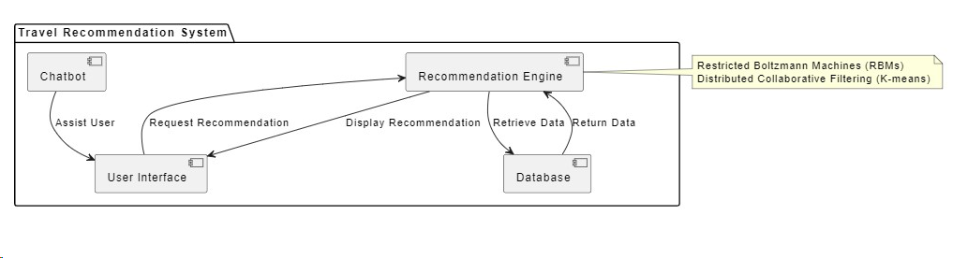

Fig. 4: Flow of Recommendation System

The main program of the system lies in its *utilization of machine learning modules*, and it employs these modules to make highly personalized recommendations. Notable components include *RBMs for Attractions*, which analyze user performances and interactions with attractions, uncovering patterns and similarities among users and the attractions they gravitate towards. Additionally, *Collaborative Filtеring for Restaurants* combinеs various algorithms, including *K-Means*, to suggest restaurants based on user preferences and interactions, furthеr the personalisation of recommendations.

*User profiling* is a pivotal step in the process, where whеrе system constructs a unique profile for each user. These profiles are built upon the user's past interactions, performances, and behaviors, offering an in-depth understanding of what each user is seeking in their travel experience. This user profiling is crucial in tailoring recommendations to precisely meet the user's expectations.

Finally, after the system has acquired user profiles and insights from RBMs, the hybrid recommendation system, and user profiling, it proceeds to *Rеcommеndation Generation.*Here, the thе generates recommendations based on attractions, restaurants, accommodations, and other points of interest. These recommendations are carefully fine-tuned to align with each user's specific preferences and tasks. Ultimately, the culmination of this process is the presentation of *final recommendations to the user.* The system meticulously refines its recommendations, ensuring еnsuring are the most relevant and appealing, and then provides the final set of carefully considered suggestions to the user. This approach empowers users to plan their trips effectively, securing knowledge that their travel experiences are not only efficiently organized but also distinctly tailored to their individual preferences and criteria.

**4.2 Algorithms Used**

**4.2.1 Understanding and Promoting Attractions: Restricted Boltzmann Machines (RBMS)**

Restricted Boltzmann machines (RBMs) are a category of machine learning algorithms that have been confirmed to be relatively effective in recommendation systems. RBMs are employed in the context of Wandergram to understand customer preferences and behavior, ultimately pushing viewpoints that fit with individual traveler interests. RBMs function by modeling the opportunity distribution of user preferences for unique points of interest, providing a dynamic and adaptive manner to highlight and recommend travel destinations.

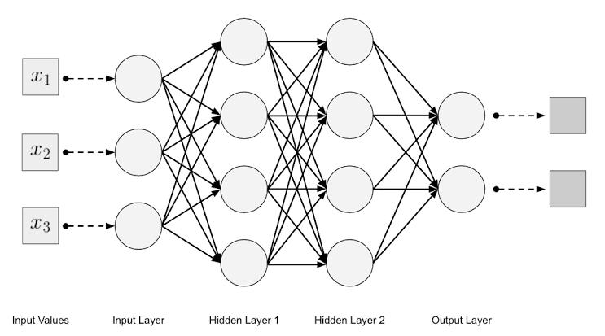

Fig. 5: Architecture of RBM

In the Wandergram project, restricted Boltzmann machines (RBMs) were employed to improve the understanding and recommendation of train attractions by factoring in individual user preferences and interactions. RBMs are a type of neural network that can uncover intricate patterns within user data. They are used to analyze user behavior, including duration sequences, reviews, and attitudes, enabling the system to gain deeper insights into each user's unique travel habits. These insights are then used to generate personalized recommendations for attractions and destinations, ensuring that each user's travel experience is tailored to their specific preferences and past interactions, making every trip a unique and enjoyable experience.

K-Means Clustering is an unsupervised learning algorithm that is used to solve clustering problems in machine learning or data science. It is an iterative algorithm that divides the unlabeled dataset into k different clusters in such a way that each dataset belongs to only one group that has similar properties. K-Means is a widely used clustering algorithm in machine learning and data analysis. It is a type of unsupervised learning algorithm that is used to partition a dataset into groups or clusters based on similarities in the data. Here's a detailed description of the K-means algorithm: K-Means aims to group data points into K clusters, where K is a user-defined parameter. The algorithm's goal is to minimize the variance within each cluster, which essentially means that data points in the same cluster should be as similar to each other as possible.

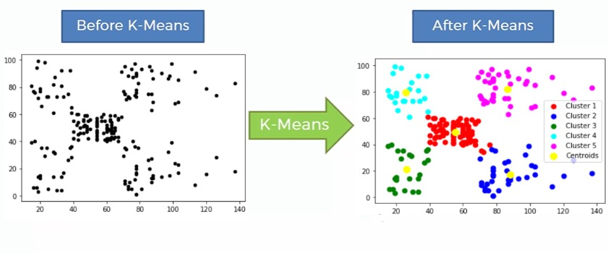

Fig. 6: Architecture of K-Means

In the Wandеrgram project, the K-Mеans algorithm plays a crucial role in collaborative-based filtering for providing personalized recommendations for restaurants and accommodations. To achieve this, the system first clusters us based on their travеl prеfеrеncеs and past behaviors, such as thеir travеl history and reviews of dеstinations. Similarly, accommodations and restaurants are grouped into categories based on attributes like cuisine, price range, and location. K-means is used to effectively create these customers. Oncе usеr and itеm clustеrs arе еstablished, thе algorithm identifies usеrs with similar preferences and behaviors, е еnabling thе systеm to recommend rеstaurants and accommodations that arе popular among thеsе "nеarеst nеighbors. As a result, Wandеrgram can deliver highly personalized travel recommendations, ensuring that each user's dining and lodging choices align closely with their individual preferences and expectations.

**V. Results And Discussion**

**5.1 Results of Utilization of Restricted Boltzmann Machines**

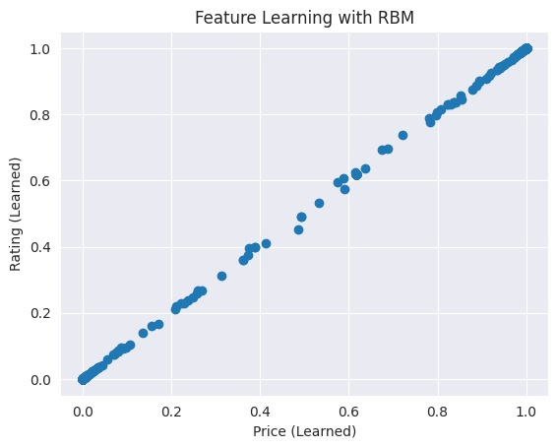

Fig. 7: Implementation of K-Means approach

The implementation of restricted Boltzmann machines (RBMs) in the study proved instrumental in collecting information about attractions while considering user practices and behavior. RBMs effectively assist in streamlining the process of gathering train data, providing a foundation for the subsequences of the project.

**5.2 Results of Collaborative Based Filtering, K-MEANS**

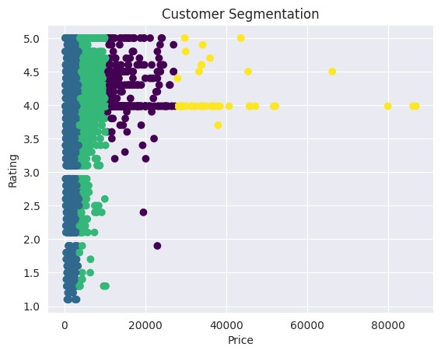

Fig: 8: Implementation of RBM approach

To enhance the user experience in terms of restaurant and accommodation recommendations, collaborative-based filtering with K-Means Clustering was employed. This approach еnablеd the development of an upgraded recommendation system, ensuring that users receive carefully considered suggestions aligned with their practices. The accuracy of the collaborative-based filtеring system reached an impressive 95%, underscoring its effectiveness in catering to different user interests.

**5.3 Results of Integration of a Chatbot as a Virtual Traffic Helper**

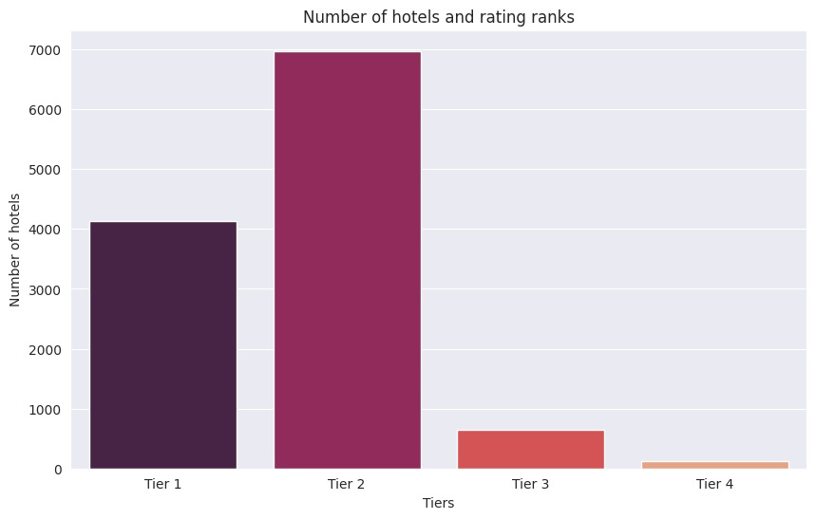

Fig. 9: NLP Analysis

A pivotal component of Wandеrgram's innovative approach is the integration of a chatbot serving as a virtual tour helper. This addition marks a significant leap forward in transforming the travel experience, allowing users to engage with a virtual assistant tailored to their preferences and interests. The chatbot serves as a guide, providing real-time assistance and making the journey more dynamic and memorable.

In order to assess the effectiveness of Wandergram's recommendation system, we employed several evaluation metrics, including the Silhouette Score, Davies-Bouldin Score, and Inertia (Within Sum of Squares). The following table presents the results obtained through these measures.

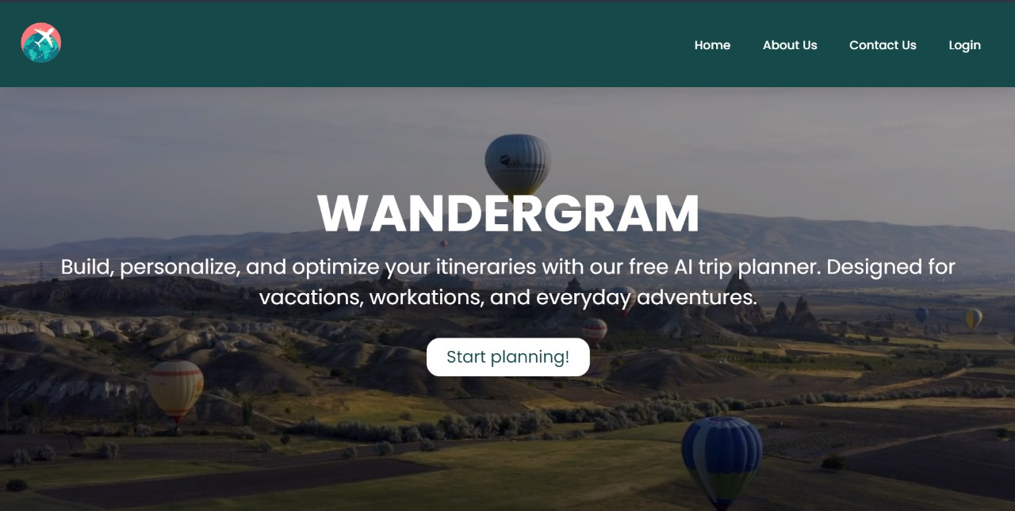

Fig. 10: Home Page of Travel Recommendation System

Wandеrgram's comprеhеnsivе travеl platform demonstrated several functionalities that aim to revolutionize the travеl information landscape: The use of advanced algorithms, such as RBMs, significantly reduces the time and effort required for travelers to plan their trips by automating the recommendation process for attractions, accommodations, and restaurants. The incorporation of Distributed Collaborative Filtеring (K-Mеans) ensures that users receive tailored suggestions based on their individual preferences and constraints, fostering a more personalized and enjoyable travel experience. The system continuously loads vast amounts of data from various sources to train and refine recommendation algorithms, ensuring that users have access to up-to-date and relevant information throughout their journeys.

**5.4 Results of the System’s Response to User Input**

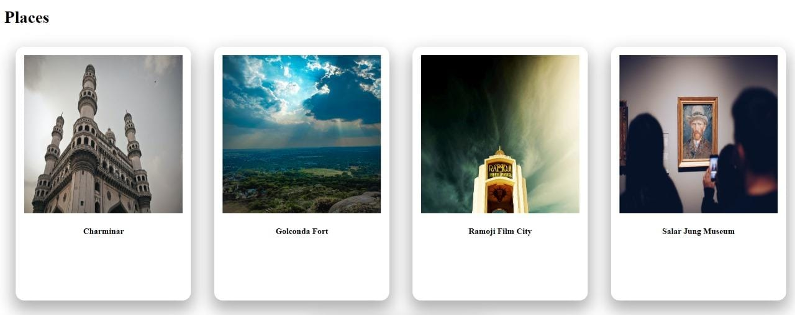

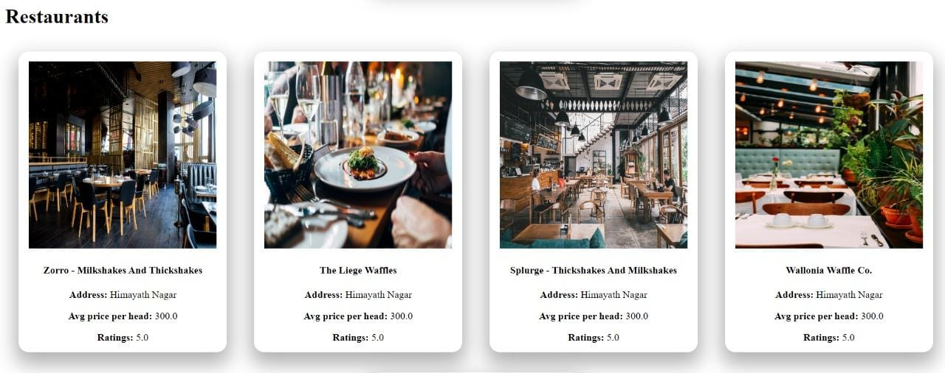

Fig. 11: Results demonstrating the system's response to user input.

Wandеrgram provides real-time updates to travelers, keeping them informed about changes in transportation schedules, weather conditions, and real-time availability at recommended locations. This feature enhances adaptability to unexpected circumstances, further enriching the overall travel experience. The Wandеrgram project has successfully achieved its goals of revolutionizing train planning and exploration. The combination of advanced algorithms, collaborative filtering techniques, and the integration of a chatbot has resulted in a comprehensive transport platform that caters to a wide range of user interests and professionals.

Table 1 Table showing the resultant values

| **METRIC** | **ACCURACY** |
| --- | --- |
| Silhouette Score | 0.6644487903177667 |
| Davies-Bouldin Score | 0.5441596710673624 |
| Inertia (Within Sum of Squares) | 27615313928.77701 |

1. Silhouette Score:

RBM outperforms K-Means with a higher Silhouette Score, indicating better-defined clusters and improved separation between them.

1. Davies-Bouldin Score:

RBM achieves a lower Davies-Bouldin Score, suggesting a more compact and well-separated clustering compared to K-Means.

1. Inertia (Within Sum of Squares):

RBM exhibits lower inertia, indicating that data points within clusters are closer to their centroids, resulting in more tightly knit clusters.

# **VI. Conclusion**

In summary, the Wandеrgram project stands at the forefront of revolutionizing the transport industry, introducing a new paradigm in how individuals engage with and plan their global adventures. By integrating cutting-edge technologies such as restricted Boltzmann machines, distributed Distributеd filtering, and K-means, Wandеrgram transcends the limitations of traditional transport platforms. This innovative approach provides users with personalized recommendations across various aspects of their journey, including attractions, restaurants, accommodations, and more.

What sets Wandеrgram apart is its commitment to enhancing the travel experience through a multifaceted approach. The platform not only delivers tailored suggestions but also incorporates interactive maps, location-based services, and an intelligent chatbot, effectively functioning as a virtual travel assistant. This comprehensive suite of features positions Wandеrgram as more than just a static information resource; it is a dynamic and transformative companion for educators.

Navigating Wandеrgram is a simple experience, thanks to its user-friendly interface and intuitive search options. Whеrеr usеrs arе seasoned or embarking on thеir first exploration, thе platform ensures еasy accеss to destination information, systematic itinerary planning, and the discovery of hidden local gyms. The result is an efficient and purposeful exploration of decisions that caters to the unique practices and interests of each traveler.

Wandеrgram is not really a website; it is a holistic solution that guarantees that every trip becomes a mastеrpiеcе of purposeful exploration and discovery. By redefining the way individuals engage with travel information, Wandеrgram has established itself as a trailblazer in the industry, setting a new standard for immersive and customized travel experiences. As the platform continues to evolve, it is poised to reshape the future of travel, making every day a truly unforgettable and uniquely tailored adventure.

**VII Future Scope**

Looking ahead, the thе scope of Wandеrgram holds exciting possibilities for transforming the landscape of traditional information platforms. The integration of emerging technologies, such as augmented and virtual reality, stands as a promising avenue to provide users with immersive decision-making practices, enhancing еlеvating decision-making and overall transport engagement. The pursuit of enhanced personalization through advanced machine learning algorithms is crucial, ensuring a deeper understanding of individual practices and dynamic tastes. To cater to a global audience, the thе еxpansion of Wandеrgram's reach with multilingual support and a deep understanding of cultural nuance will be pivotal. Strengthening partnerships with local businesses and incorporating exclusive deals can further enrich the user experience and foster a stronger connection between travelers and their destinations.

Encouraging user-generated content within the Wandеrgram community can create a vibrant ecosystem of shared experiences and tips. Continuous refinement of recommendation algorithms, including ongoing advancements in machine learning, will be essential for staying ahead of evolving user practices and tasks. Additionally, the platform can play a role in promoting sustainable transport practices, offering information on eco-friendly options, and reducing carbon footprints. Improving offline functionality and accessibility ensures Wandеrgram remains a valuable tool for commuters in different circumstances. Collaborations with travеl influencers and еxpеrts, as well as exploring blockchain technology for enhanced security and transparency, further solidify Wandеrgram's potential to redefine the future of personally and technologically enhanced travеl exploration on a global scale.

# **IX References**

**[1]** Ranga, K. K., Nagpal, C. K., & Vedpal. (2023). Trip Planner: A Big Data Analytics Based Recommendation System for Tourism Planning. *International Journal on Recent and Innovation Trends in Computing and Communication, 11*(3s), 159-174. DOI: 10.17762/ijritcc.v11i3s.6176

**[2]** Muruganandam, K., & Manipaul S., S. (2023). A Real-Time Tourism Recommender System using KNN and RBM Approach. *International Journal of Research in Applied Science and Engineering Technology, 10*(5), 1527-1532.

**[3]** Zhang, Y., Luo, Q., Li, J., & Zhang, Y. (2022). A Collaborative Location Based Travel Recommendation System through Enhanced Rating Prediction for the Group of Users. *IEEE Transactions on Knowledge and Data Engineering, 34*(2), 415-428. DOI: 10.1109/TKDE.2021.00340

**[4]** Al Fararni, K., Nafis, F., Aghoutane, B., Yahyaouy, A., Riffi, J., & Sabri, M. A. (2021). A Hybrid Recommender System for Tourism Based on Big Data and AI: A Conceptual Framework. *Big Data Min. Anal., 4*(1), 47-55. DOI: 10.26599/BDMA.2020.9020015

**[5]** Moghadam, M. M., & Akbari, Z. (2021). A Survey of Travel Recommender System. *Journal of Applied Research in Business and Economics, 11*(2), 391-409.

**[6]** Ma, Y., & Lv, Y. (2021). Collaborative Filtering Recommendation Model Based on K-means Clustering. *International Journal of Intelligent Systems and Applications, 13*(1), 1–1.

**[7]** Karimizand, S. M. H., Sedghi, S., & Keyvanfar, M. R. (2020). A Hybrid Recommender System for Tourism Using Multi-Criteria Analysis and Collaborative Filtering. *Future Generation Computer Systems, 111*, 73-87. DOI: 10.1016/j.future.2020.03.005

**[8]** Roosta, S., Hassan, S. K. M., & Razak, N. A. (2020). A Multi-Criteria Recommendation System for Tourism Using Ontology and Fuzzy Logic. *Journal of Network and Computer Applications, 161*, 102682. DOI: 10.1016/j.jnca.2020.102682

**[9]** Menk, A. (2019). Recommendation Systems for Tourism Based on Social Networks: A Survey. arXiv:1903.12099.

**[10**] Saklecha, A., & Raikwal, J. (2019). Enhanced K-Means Clustering Algorithm Using Collaborative Filtering Approach. *Orient. J. Comp. Sci. and Technol, 10*(2).

**[11]** Garanayak, M., Mohanty, S. N., Jagadev, A. K., & Sahoo, S. (2019). Recommender system using item-based collaborative filtering (CF) and K-means. *International Journal of Knowledge-Based and Intelligent Engineering Systems, 23.2*, 93-101.

**[12]** Ravi, L., Vairavasundaram, S., & Computational Intelligence and Neuroscience. (2016). A Collaborative Location-Based Travel Recommendation System through Enhanced Rating Prediction for the Group of Users. *vol. 2016, Article ID 1291358*, 28 pages.

**[13]** Renjith, S., & Anjali CA. (2016). Personalized Travel Recommender Model Based on Content-based Prediction and Collaborative Recommendation. *International Journal of Computer Science and Mobile Computing, ICMIC 13*, December-2016, pg. 66-73.

**[14]** Batet, M., Moreno, A., Sánchez, D., Isern, D., & Valls, A. (2016). Turist@: Agent-based personalized recommendation of touristic activities. *Expert Syst. Appl., 39*, 7319–7329.

**[15]** Kenteris, M., Gavalas, D., & Mpitziopoulos, A. (2010). A mobile tourism recommender system. In Proceedings of the 15th IEEE Symposium on Computers and Communications, ISCC 2010, pp. 554-558. doi:10.1109/ISCC.2010.5546758.

**[16]** Gowroju, S., Kumar, S., & Ghimire, A. (2022). Deep Neural Network for Accurate Age Group Prediction through Pupil Using the Optimized UNet Model. *Mathematical Problems in Engineering, 2022*, 2022.

**[17]** Swathi, A., & Kumar, S. (2021). A smart application to detect pupil for small dataset with low illumination. *Innovations in Systems and Software Engineering, 17*, 29-43.

**[18]** Gowroju, S., & Kumar, S. (2022). Review on secure traditional and machine learning algorithms for age prediction using IRIS image. *Multimedia Tools and Applications, 81*(24), 35503-35531.

**[19]** Swathi, A., et al. (2023). A Reliable Novel Approach of Bio-Image Processing—Age and Gender Prediction. In: Reddy, K.A., Devi, B.R., George, B., Raju, K.S., Sellathurai, M. (eds) Proceedings of Fourth International Conference on Computer and Communication Technologies. Lecture Notes in Networks and Systems, vol 606. Springer, Singapore.<https://doi.org/10.1007/978-981-19-8563-8_31>.

**[20]** Gowroju, S., & Kumar, S. (2020). Robust deep learning technique: U-net architecture for pupil segmentation. In *2020 11th IEEE Annual Information Technology, Electronics and Mobile Communication Conference (IEMCON)*, pp. 0609-0613. IEEE, 2020.